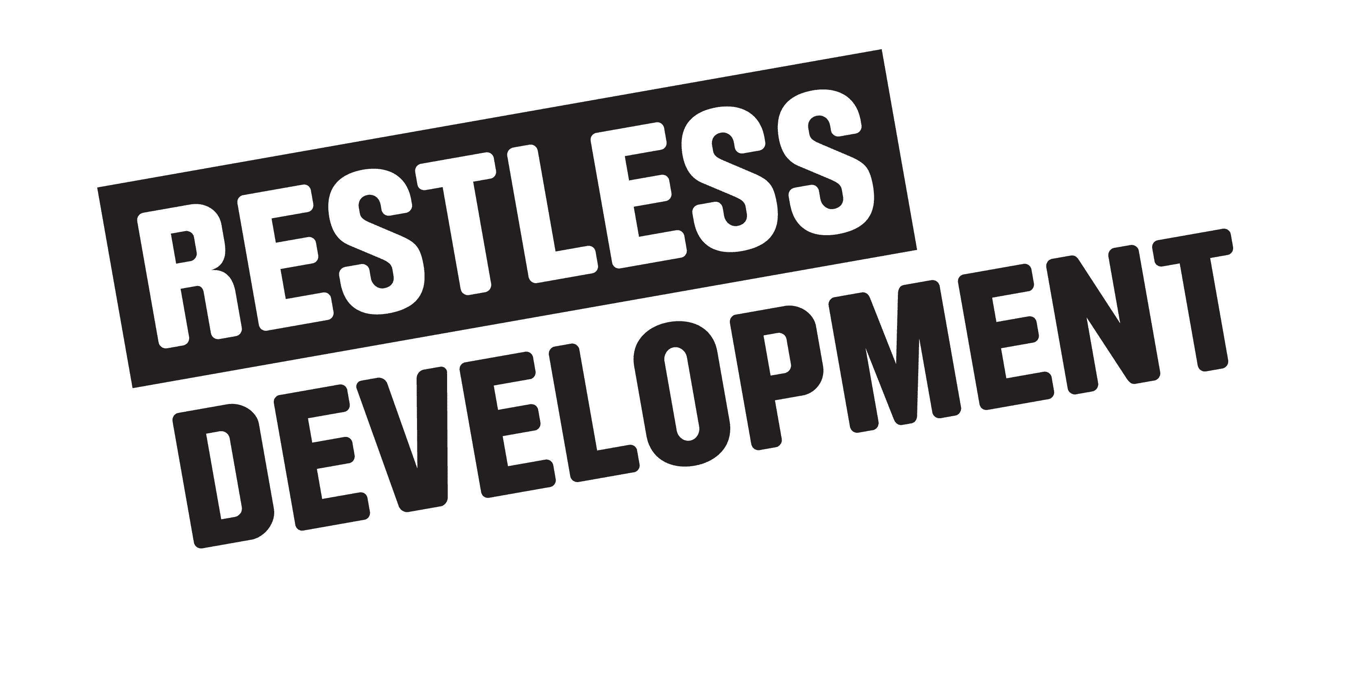

APPLICATION FORM:

Youth researchers Team Members

- All information collected on this application form is held in the strictest of confidence.
- Selection of successful candidates will be carried out solely on the basis of information provided on this application form. CVs will not be considered.
- Please complete and return this application form to info@reachahand.org
- Deadline for submission is Friday 9th March 2018
- For more information contact Ibrahim on bata@reachahand.org or phone 0702010477

PROJECT DESCRIPTION:
Restless Development Uganda in partnership with AfriYAN received a 2 year extension for the My Voice My Rights Programme (1718 and 1819) being implemented in eastern Uganda. The aim of this programme, is to empower young people, men and young women realize their sexual and reproductive health rights. The programme has 3 main objectives;
- To influence SRHR planning and decision making processes both at district and national level.
- To increase access to SRHR information and services,
- Changing social norms (challenging stigma, discrimination, attitudes and practices that impact on young people’s SRHR).
- Strengthen the SRHR network
The programme has 5 outcome indicators and AfriYAN through Reach A Hand Uganda specifically leads on the outcome of; New evidence on SRHR generated, or existing evidence synthesized, or major gaps in SRHR knowledge/ attitudes/ behaviour synthesized, which is used for evidence-based advocacy and policy engagement.
We are currently looking for open minded, self-motivated, enthusiastic and highly committed young men & women to lead research in the communities of Buyende, Pallisa, Butaleja and Manafwa aged (18-28). Interested candidates for this post will be expected to be available from March 2018 to September 2018.
If interested please complete the application form, attach all the relevant documents and submit to info@reachahand.org with the subject: MVMR Youth Researcher Application
The deadline for applications is 21th March 2018 (Successful applicants will be contacted directly).

Section 1: Personal, Contact Details & Placement
  - Personal Details
First name(s):
Family Name:
Nationality:
Date of Birth:
Have you ever participated in any research and advocacy work before? Yes / No ( Tick most appropriate)
Are you part of any youth platform/ or club or ever participated in any research programme? Yes / No ( Tick most appropriate)
If yes, please provide more details

Have you ever done youth work before? Yes / No ( Tick most appropriate),
If yes, please provide more details.

  - Address & Contact Numbers – Please include location address of where you are currently staying.ie Buyende, Pallisa, Butaleja and Manafwa Dstricts
Physical Address:
District: Sub county; Village
Telephone (Personal):
Telephone (Home):
Telephone for Next of Kin:
Email Address:

SECTION II: YOUR EDUCATION

O’Level results
..................................................................................................................................................................................................................................................................................................................................
..................................................................................................................................................................
..................................................................................................................................................................................................................................................................................................................................
.A ‘Level results
....................................................................................................................................................................................................................................................................................................................................
..................................................................................................................................................................................................................................................................................................................................
Any other qualification attained and results ..................................................................................................................................................................................................................................................................................................................................
..................................................................................................................................................................................................................................................................................................................................
University attended (if applicable)...................................................................................................................................................................................................................................................................................................................
Degree and result (if applicable).................................................................................................................................................
..................................................................................................................................................................
LANGUAGE SKILLS – Tick most appropriate
ENGLISH | Spoken | Fluent | Fair | Poor
 | Written | Fluent | Fair | Poor
Others (Specify) | Spoken | Fluent | Fair | Poor
 | Written | Fluent | Fair | Poor
Other Specify and rank……………… | Spoken…………… | Written………………………

Outline your relevant experience related to research and advocacy
Details of your previous experience | Period
Availability and commitment

Are you able to commit to work with AfriYAN for a period from March 2018 to September 2018?
NO
YES
(please circle/tick)

Please answer the following questions to indicate your suitability for this position:
- Why do you wish to become a Youth Researcher in your District?

- In a paragraph of not more than 100 words explain what you understand by the term research and advocacy?

- Mention the necessary experience and skills you have with specific examples of working with the youth advocacy programs? Explain how you will use these skills on the programme.

- Outline the challenges you anticipate being a Youth Researcher in your District?

- Please select one of the challenges above and suggest how you would overcome it while on the My Voice My Rights Programme.

- Please mention and explain 3 Adolescent Sexual and reproductive health issues that young people face in Uganda and how they can be addressed?

Participating in the research as a team leader. (This following sections MUST be completed by those interested in participating on the programme as team leaders)

This program gives young people a chance to participate in the programme as Team leaders, show your interest in this role by Ticking in the Box below.

yes

Team Leader Skills and competencies
Qn1.What leadership skills do you poses as an individual? How will these help you in performing your role as a team leader?

Motivation
Qn2. Using not more 200 words, tell us about your motivation and experience in leadership

I DECLARE THAT TO THE BEST OF MY KNOWLEDGE AND BELIEF THE INFORMATION GIVEN ON THIS FORM IS CORRECT.
Signed: Date:

Important:
- Must be a Uganda aged 18 to 28.
- Must have ‘O’ Level, A-Level, Diploma or University Qualifications.
- Demonstrate knowledge of, or Interest in Adolescent Sexual Reproductive Health issues and advocacy.
- Must be a resident of Buyende, Pallisa, Butaleja, Manafwa, Jinja, and Mayuge willing to conduct research in the local communities of these Districts.
- Should be fluent in the local languages of the above districts.
- Express knowledge of or Interest in research and advocacy.
- Experience of facilitating community dialogues and youth meetings.
- Demonstrated ability to connect with fellow young people in his/her District.
- Ability to participate in the programme between March 2018 to September 2018.

This form should be submitted electronically at info@reachahand.org with the subject MVMR Youth Researcher Application. The closing date for applications is Friday 21th March 2018

